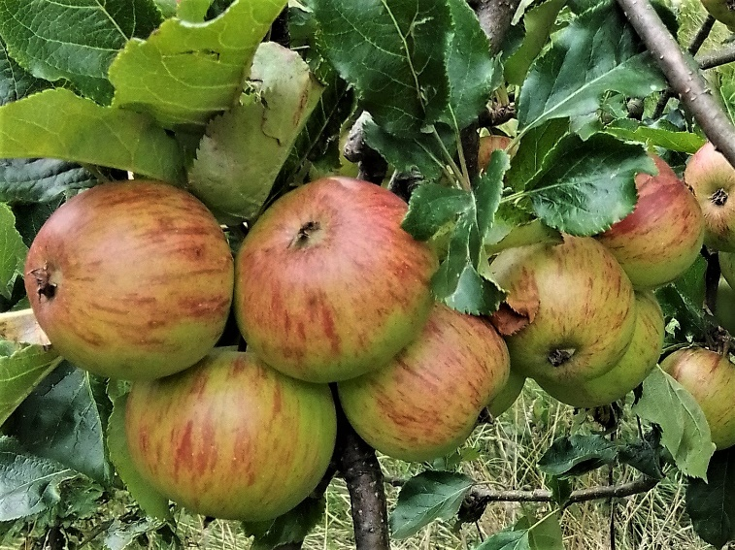

FAVOURITE APPLE RECIPES
www.transitiontownromsey.weebly.com/transitiontownromseyweebly@gmail.com

Blackberry & Apple Cake (Nigel Slater / Sainsbury’s Magazine)
Serves: 8-10 Oven Temperature: 180C/Fan 160C/Gas 4
Ingredients:
For the Cake: For the Crumble:
150g / 5oz Softened Butter 100g / 3 ½ oz Cold Butter
150g / 5oz Caster Sugar 100g / 3 ½oz Plain Flour
3 Large Eggs 110g / 4oz Demerara Sugar
75g / 3oz Plain Flour 2 tbsp Whole Rolled Oats
1 ½ tsp Baking Powder A ‘knifepoint’ Ground Cinnamon
110g / 4oz Ground Almonds Icing Sugar for dusting
1 Large Desert Apple
150g / 5oz Blackberries

Method:
1. To make the cake:
Cream the butter and sugar until light and fluffy. Break the eggs into a bowl, beat lightly with a fork, and add them bit by bit to the sugar and butter. Add a little flour if it begins to curdle. Mix flour and baking powder together and then add slowly to the mixture with a metal spoon, followed by the ground almonds. Spoon the mixture into a 20cm/8” deep, loose-bottomed tin, lined with baking parchment, and smooth the top.
Core and peel the apple and cut into about 16 thin slices. Push the slices into the top of the cake mixture and tip the blackberries on top.
2. To make the crumble:
Rub the butter into the flour until it resembles breadcrumbs, then add the sugar, oats and cinnamon. Scatter mixture over the top of the cake.

Bake for 1 hour, then test with a skewer to see if it’s cooked. The fruit will still be slightly wet, but the cake mix should be cooked. Leave the cake to cool, then dust with icing sugar.

American Apple Cake (Marguerite Patten)
Serves: 12

Ingredients:
10 oz / 250 g Self-Raising Flour
1 level tsp Baking Powder
1 oz / 25 g Castor Sugar
¾ tsp Salt
4 oz / 100 g Butter or Margarine
2 oz / 50 g Grated Cheese
About ¼ pt / 125 ml Milk
4 Eating Apples
2-3 oz / 50-75 g Brown Sugar
½ tsp Cinnamon
1 tbsp Melted Butter

Method:
1. Sift flour, baking powder, castor sugar and salt together.
2. Rub in butter or margarine and then mix in cheese.
3. Add sufficient milk to make a soft, but not sticky, dough.
4. Turn on to a floured board and knead dough lightly.
5. Pat out dough in ungreased Swiss Roll tin (approx 7x10” / 18x25cm).
6. Pare and core apples, slice thinly. Arrange in rows across dough.
7. Sprinkle with brown sugar and cinnamon mixed together.
8. Brush over with melted butter.
9. Bake for 25 minutes at 220C / Gas 7.
10. Serve sliced with coffee.
Apple & Cinnamon Oatmeal Cookies
A delicious, soft cake-like cookie, filled with oats, loaded with tiny chunks of apples, and swirled with plenty of cinnamon.
Makes: 15 Cookies. Prep: 15 minutes Cook: 30 minutes
Ingredients:
1 ¼ cups (117g) Self Raising flour
1 ¼ cups (120g) Oatmeal
1 tsp ground Cinnamon
½ tsp Baking Soda
¼ tsp Salt
½ cup (113g) unsalted Butter, softened
¾ cup (160g) packed light Brown Sugar
1 large Egg
1 tsp vanilla extract
1 cup (120g) finely chopped & peeled Apples

2 tsp fresh Lemon Juice
Instructions
1. Preheat oven to 180C. Line two baking sheets with parchment paper, or grease them.
2. In a mixing bowl, mix together flour, oatmeal, cinnamon, baking soda and salt for 20 seconds, set aside.
3. In a bowl, cream together butter and brown sugar until combined. Mix in egg and vanilla extract.
4. Toss apples with lemon juice in a small bowl. Add flour mixture to egg and vanilla mixture and mix until combined. Then mix in the apples.
5. Scoop dough out and drop onto prepared baking sheets, spacing cookies 2 inches apart. Flatten them just slightly.
6. Bake in the preheated oven until cookies are set, about 14-15 minutes.
7. Let cool on baking sheet for several minutes, then transfer to a wire rack to cool completely.
Betty Crocker’s Old Fashioned Apple Cookies

Ingredients:
1 cup packed Brown Sugar
½ cup Butter or Margarine, softened
1 Egg
1 ½ cups Plain Flour
1 tsp ground Nutmeg
½ tsp Salt
½ tsp Baking Soda
1 medium Apple, peeled and chopped quite small (1 cup)

Instructions
1. Heat oven to 180C. Grease cookie sheet with shortening.
2. Beat brown sugar, butter and egg in large bowl with electric mixer on medium speed until light and fluffy.
3. Stir in flour, nutmeg, salt and baking soda. Stir in apple.
4. Drop dough by rounded teaspoonfuls about 2 inches apart onto cookie sheet.
5. Bake 8 to 10 minutes or until light brown. Remove from cookie sheet to wire rack. Cool. Store loosely covered.
Why not try other fruit and vegetables for a change. Good substitutes for the apple are pears, bananas, courgettes and carrots.

Apple and Pork Harissa Samosas

Ingredients:
Cooking oil
1 med Red Onion, finely diced
250g Pork Mince
1 tsp ground Ginger
1 tsp ground Cinnamon
1 tbsp rose Harissa Paste
1 Eating Apple, diced
Juice of 1 Lemon
2 tbsp of fresh chopped Herbs, such as sage, mint, thyme, etc.
Salt and ground Black Pepper
Filo Pastry
Oil for brushing
1 Egg
Cooking oil spray

Method:
1. Place the lemon juice in with the diced apple pieces to prevent browning
2. In a frying pan, on a medium heat, put in the diced red onion, pork mince, ground ginger and ground cinnamon, and cook for 10 minutes, so the mince is just cooked and the mixture is not too wet
2. Stir in the rose harissa and cook for a further 2 minutes. Season to taste with salt and ground black pepper. If you like, stir in more harissa paste for a hotter mix
3. Turn the heat off and leave to cool slightly before stirring in the chopped fresh herbs and the apple pieces, together with the lemon juice. Set aside while preparing the filo pastry sheets
4. Take two filo pastry sheets - lay one down in landscape mode, brush lightly with oil, top with the second one, brush it with oil again. Take a sharp knife and cut 5 equal sized strips.
5. Take one strip, and cover the rest with a barely damp tea towel to stop them from drying out
6. Place the strip with the shorter side nearest to you and put a dessert spoonful of the pork and apple mixture along the bottom edge
7. Bring the lower right hand corner of the pastry strip to meet up with the left hand edge (on the long side), making a tight triangle. Repeat along the length then place some water on the strip before the last fold to secure the parcel. Place on a baking tray
8. Repeat with the rest of the filo pastry strips until all the mixture has been used up
9. Beat the egg with a little water and brush on the filo pastry parcels. Chill until needed
10. To cook them, preheat the oven to 220C/200C fan. Lightly spray the filo parcels with a cooking oil spray, then cook for 10-14 minutes until golden brown

Apple & Sultana Scone (ASDA)

Cooking Time: 25 minutes Temperature: 200C/400F/Gas Mark 6

Ingredients:
8oz / 200g Self Raising Flour
½ teaspoon Salt
2oz / 50g Margarine
2oz / 50g Caster Sugar
1 Medium Cooking Apple, peeled and chopped
4oz / 100g Sultanas
1 Egg beaten

Method:
1. Sieve the flour and salt into a mixing bowl. Rub the margarine into the flower until it resembles fine breadcrumbs
2. Stir in the sugar, chopped apple and sultanas.
3. Add the the beaten egg to form a soft dough.
4. Shape the dough into a round. Place it on a greased baking tray and mark into wedges.
5. Bake until well risen and golden.

Apple & Cinnamon Squares (Daily Mirror)

Cooking Time: 30-40 minutes Temperature: 190C/375F

Ingredients:
6oz Self Raising Flour
2 teaspoons Cinnamon
4oz Margarine
4oz Caster Sugar
2 size 3 Eggs
4 tablespoon Milk
1 lb Cox’s Apples, peeled, chopped small
2 tablespoons Soft Brown Sugar

Method:
1. Sift flour and cinnamon into a bowl.
2. In a separate bowl, beat margarine and sugar until light and fluffy, then add eggs one at a time, with a little of the sifted flour. Beat well.
3. Fold in the remaining flour and milk to give a dropping consistency.
4. Fold in the chopped apples.
5. Spoon into a greased 11” x 7” (18 x 25cm) shallow baking tray and sprinkle with the brown sugar.
6. Bake until golden brown and firm to touch.
7. Leave to cool, then cut into squares.

Apple Stuffing (Romsey School)

Ingredients:
2oz Breadcrumbs
1 Onion, chopped small
1 small Eating Apple
1oz melted Butter

Method:
1. Grate apple and add to the breadcrumbs.
2. Chop onion and add.
3. Bind together with melted butter.
4. Put in ovenproof dish and bake for 15 mins in a hot oven until brown.

Cider & Apple Sorbet (Safeway)
Makes: 1 ½ pints.

Ingredients:
8 oz granulated Sugar
½ pint Water
2 medium, sweet Eating Apples
½ pint medium sweet Cider
Juice of a Lemon

Method:
1. Slowly dissolve sugar in water over a medium heat. Bring to the boil and boil rapidly for 5 minutes.
2. Slice the apples and cook with a little water over a medium heat for 5-10 minutes until soft. Sieve and add to sugar syrup.
3. Cool, and stir in cider and lemon juice.
4. Put in freezer. When almost frozen, beat it to break down the ice crystals. Continue freezing.

Apple Scones

Ingredients:
8oz plain flour + 3tsp baking powder or 8oz Self Raising flour
4oz butter or margarine
2oz sugar
8oz apples (after peeling and coring)
milk

Method:
1. Rub the butter into the flour.
2. Grate or very finely chop the apples and mix with the sugar. Add to the flour.
3. Add enough milk to make a soft dough.
4. Form into a round about 3/4" inch thick. Mark with a knife into 8 portions.
5. Bake on a greased tin in a hot oven (425 F, Gas 7) for 25-30 mins.
6. Serve whilst still warm, split and buttered. Any left over can be toasted.

Acknowledgements have been made to the recipe source whenever possible.

RECIPE BOOKLETS

SUGGESTED DONATION
50p

