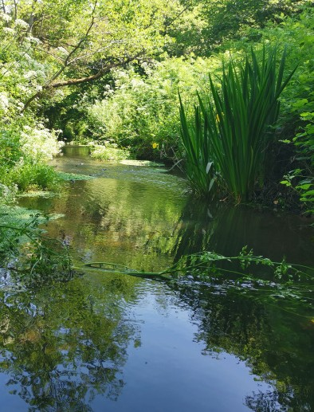
Valley Park Woodlands Local Nature Reserve, Chandlers Ford

Grid reference: SU420203
Comprising of ancient woodland with a mixture of woodland rides, open
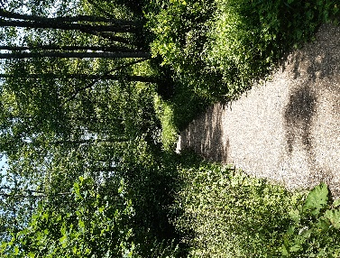
glades, ponds and rough grassland, the woodlands have been managed by Test Valley Borough Council since 1998. Rich in wildlife as well as archaeology the woodland is home to a variety of species including pipistrelle bats, roe deer and a host of insects and plant life. The site is thought to be derived from the historic Baddesley Common complex and has close characteristics with the New Forest. It also boasts the remnants of an Iron Age
enclosure and associated features.

Tadburn Meadows Local Nature Reserve, Romsey
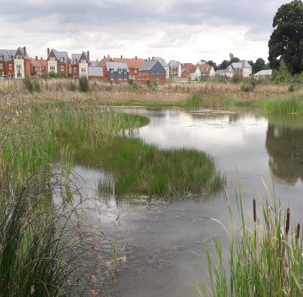
Grid reference: SU367214 Hidden amongst the houses, Tadburn Meadows covers almost 12 acres and
provides a home for a variety of Britain’s best loved wildlife and some nationally threatened species. The site boasts a variety of habitats, from a stream more characteristic of the New Forest, to wet woodland and grassland.

Abbotswood Nature Reserve, Romsey

Grid reference: SU364228
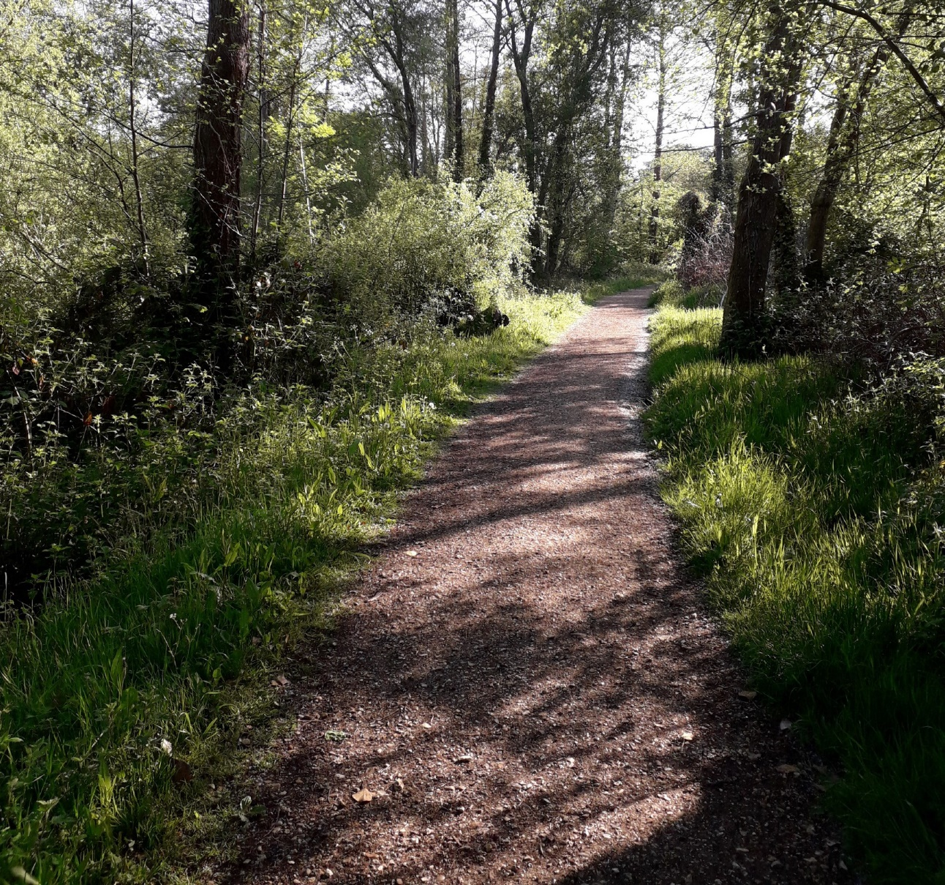
Abbotswood Nature Reserve, located adjacent to the Abbotswood
South Test Valley
TestValleyBC
TestValleyBC
www.testvalley.gov.uk
development, has been designated primarily due to the presence of great crested newts,
a European protected species. The site contains a host of interesting habitats, including wetlands, ancient semi- natural woodland and grassland. These support a wealth of wildlife. The site also boasts veteran oak trees, estimated to be over 300 years old and each a home to hundreds of other species, making them a hugely important part of the site.
Parks and Countryside Events and Activities 2024

Local Conservation Groups

Tadburn Conservation Volunteers
A local volunteers group working on Tadburn Meadows Local Nature Reserve, Romsey. For more information contact: tadburn.meadows@gmail.com

Friends of the Parks
A local volunteer group working in Valley Park Woodlands Local Nature Reserve, Chandlers Ford. Contact Steve White on 02380 263204 or fotp@btinternet.com

Wilder Romsey
A local conservation group working in and around Romsey. Contact: community&leisure@testvalley.gov.uk

Test Valley Parks and Countryside Team
The team work to maintain and develop the borough’s green spaces which include countryside sites, Nature Reserves, parks and cemeteries.
Please contact the countryside officers in advance for more details. Further information is available on www.testvalley.gov.uk
Or contact the Countryside Officers on 01264 368000, or email community&leisure@testvalley.gov.uk
Thank you to everyone who has volunteered throughout 2023 to help maintain and enhance our green spaces.
New volunteers, including families, are always welcome to help with the on-going programme of events.

Parks and Countryside Events and Activities Guide 2024 South Test Valley

Date | Time | Task | Venue | Meeting Place
Sat 6 Jan | 10am to 1pm | Coppicing/ Bramble clearance | Abbotswood Nature Reserve | Abbotswood Sports Ground
Sun 14 Jan | 10am to 2pm | Holly thinning & bonfire | Valley Park LNR, Knightwood Copse | Violet Close Playground
Wed 17 Jan | 1pm to 4pm | Vegetation control | Romsey Barge Canal | New Road Car Park
Sat 20 Jan | 10am to 12pm | Coppicing | Tadburn Meadows Local Nature Reserve | Eight Acres
Sat 3 Feb | 10am to 1pm | Tree guard removal | Abbotswood Nature Reserve | Abbotswood Sports Ground
Sun 18 Feb | 10am to 12pm | River coppicing/laying | Tadburn Meadows Local Nature Reserve | Eight Acres
Sun 18 Feb | 10am to 12pm | Tree planting | Valley Park LNR, Skys Wood | Top of Morgan Le Fay
Sun 17 Mar | 10am to 12pm | Coppicing | Valley Park LNR, Zionshill East | Leisure Centre
Sun 14 Apr | 10am to 12pm | Sycamore bashing | Valley Park LNR, Skyswood | Top of Morgan Le Fay
Sat 20 April | 10am to 12pm | Path maintenance | Tadburn Meadows Local Nature Reserve | Eight Acres
Sun 9 Jun | 10am to 12pm | Heath management | Valley Park LNR, Zionshill East | Leisure Centre
Sun 23 June | 10am to 12pm | Himalayan Balsam Removal | Tadburn Meadows Local Nature Reserve | Eight Acres
Sun 7 Jul | 10am to 12pm | Bracken management | Valley Park LNR, Tredgoulds Copse | Top of Yewberry Way
Sat 20 July | 10am to 12pm | Discovery Day | Tadburn Meadows Local Nature Reserve | Eight Acres
Sat 3 Aug | 10am to 12pm | Himalayan Balsam Removal | Tadburn Meadows Local Nature Reserve | Eight Acres
Fri 30 Aug | 8pm onwards | Bat Walk | Tadburn Meadows Local Nature Reserve | Eight Acres
Sun 15 Sep | 10am to 12pm | Coppicing | Valley Park LNR, TBC | TBC
Sun 6 Oct | 10am to 12pm | Pond maintenance | Tadburn Meadows Local Nature Reserve | Eight Acres
Sun 13 Oct | 10am to 12pm | Coppicing | Valley Park LNR, Skyswood Copse | Top of Morgan Le Fay
Wed 23rd Oct | 10am - 1pm | Wilder Romsey- TBC | TBC | TBC
Sat 9th Nov | 10am - 1pm | Wilder Romsey- TBC | TBC | TBC
Sun 17 Nov | 10am to 12pm | Ride management | Valley Park LNR, Zionshill East | Leisure Centre
Sat 23 Nov | 10am to 12pm | Non-native species control | Tadburn Meadows Local Nature Reserve | Eight Acres
Wed 27th Nov | 10am - 1pm | Wilder Romsey- TBC | TBC | TBC
Sun 8 Dec | 10am to 12pm | Meadow management | Valley Park LNR, Main meadow | Leisure Centre
Sat 14th Dec | 10am - 1pm | Wilder Romsey- TBC | TBC | TBC

Important Note
The practical tasks that we carry out on our Green Spaces and Nature Reserves can be strenuous,
tiring and involve the use of hand tools that some people may find challenging. Please inform the co-ordinator leading the event if you have any medical conditions or concerns that could be a danger to yourself or other volunteers working around you. We reserve the right to restrict your level of participation in certain circumstances. All children under the age of 16 must be accompanied by a responsible adult.

