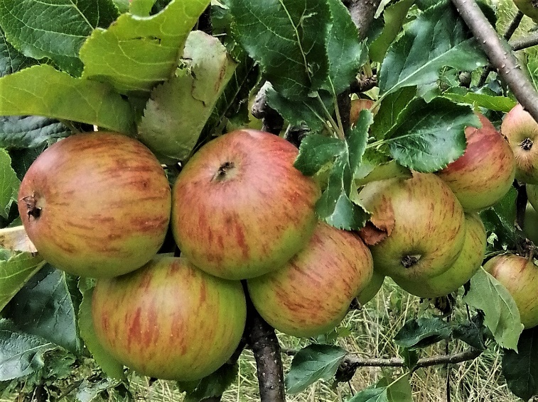

FAVOURITE APPLE RECIPES

www.transitiontownromsey.weebly.com/transitiontownromseyweebly@gmail.com

Blackberry & Apple Cake (Nigel Slater / Sainsbury’s Magazine)
Serves: 8-10 Cooking Time: 1 hr Oven Temperature: 180°C /Fan 160°C /Gas 4
Ingredients:
For the Cake: For the Crumble:
150g / 5oz Softened Butter 100g / 3 ½ oz Cold Butter
150g / 5oz Caster Sugar 100g / 3 ½oz Plain Flour
3 Large Eggs 110g / 4oz Demerara Sugar
75g / 3oz Plain Flour 2 tbsp Whole Rolled Oats
1 ½ tsp Baking Powder A ‘knifepoint’ Ground Cinnamon
110g / 4oz Ground Almonds Icing Sugar for dusting
1 Large Desert Apple
150g / 5oz Blackberries

Method:
1. To make the cake:
Cream the butter and sugar until light and fluffy. Break the eggs into a bowl, beat lightly with a fork, and add them bit by bit to the sugar and butter. Add a little flour if it begins to curdle. Mix flour and baking powder together and then add slowly to the mixture with a metal spoon, followed by the ground almonds. Spoon the mixture into a 20cm/8” deep, loose-bottomed tin, lined with baking parchment, and smooth the top.
Core and peel the apple and cut into about 16 thin slices. Push the slices into the top of the cake mixture and tip the blackberries on top.
2. To make the crumble:
Rub the butter into the flour until it resembles breadcrumbs, then add the sugar, oats and cinnamon. Scatter mixture over the top of the cake.

Bake for 1 hour, then test with a skewer to see if it’s cooked. The fruit will still be slightly wet, but the cake mix should be cooked. Leave the cake to cool, then dust with icing sugar.

American Apple Cake (Marguerite Patten)
Serves: 12 Cooking Time: 25 Minutes Oven Temperature: 220°C /Gas 7
Ingredients:
10 oz / 250 g Self-Raising Flour
1 level tsp Baking Powder
1 oz / 25 g Castor Sugar
¾ tsp Salt
4 oz / 100 g Butter or Margarine
2 oz / 50 g Grated Cheese
About ¼ pt / 125 ml Milk
4 Eating Apples
2-3 oz / 50-75 g Brown Sugar
½ tsp Cinnamon
1 tbsp Melted Butter

Method:
1. Sift flour, baking powder, castor sugar and salt together.
2. Rub in butter or margarine and then mix in cheese.
3. Add sufficient milk to make a soft, but not sticky, dough.
4. Turn on to a floured board and knead dough lightly.
5. Pat out dough in ungreased Swiss Roll tin (approx 7x10” / 18x25cm).
6. Pare and core apples, slice thinly. Arrange in rows across dough.
7. Sprinkle with brown sugar and cinnamon mixed together.
8. Brush over with melted butter.
9. Bake for allotted time.
10. Serve sliced with coffee.
Apple & Cinnamon Oatmeal Cookies (Cooking Classy)

A delicious, soft cake-like cookie, filled with oats, loaded with tiny chunks of apples, and swirled with plenty of cinnamon.
Makes: 15 Cookies. Cooking Time: 14-15 minutes Oven temperature: 180°C
Ingredients:
1 ¼ cups (117g) Self Raising flour
1 ¼ cups (120g) Oatmeal
1 tsp ground Cinnamon
½ tsp Baking Soda
¼ tsp Salt
½ cup (113g) unsalted Butter, softened
¾ cup (160g) packed light Brown Sugar
1 large Egg
1 tsp vanilla extract
1 cup (120g) finely chopped & peeled Apples
2 tsp fresh Lemon Juice

Method:
1. Preheat oven. Line two baking sheets with parchment paper, or grease them.
2. In a mixing bowl, mix together flour, oatmeal, cinnamon, baking soda and salt for 20 seconds, set aside.
3. In a bowl, cream together butter and brown sugar until combined. Mix in egg and vanilla extract.
4. Toss apples with lemon juice in a small bowl. Add flour mixture to egg and vanilla mixture and mix until combined. Then mix in the apples.
5. Scoop dough out and drop onto prepared baking sheets, spacing cookies 2 inches apart. Flatten them just slightly.
6. Bake in the preheated oven until cookies are set, about 14-15 minutes.
7. Let cool on baking sheet for several minutes, then transfer to a wire rack to cool completely.

Apple & Sultana Scones (ASDA Sultana Packet)

Cooking Time: 25 minutes Oven Temperature: 200°C /400°F/Gas Mark 6

Ingredients:
8oz / 200g Self Raising Flour
½ teaspoon Salt
2oz / 50g Margarine
2oz / 50g Caster Sugar
1 Medium Cooking Apple, peeled and chopped
4oz / 100g Sultanas
1 Egg beaten

Method:
1. Sieve the flour and salt into a mixing bowl. Rub the margarine into the flower until it resembles fine breadcrumbs
2. Stir in the sugar, chopped apple and sultanas.
3. Add the the beaten egg to form a soft dough.
4. Shape the dough into a round. Place it on a greased baking tray and mark into wedges.
5. Bake until well risen and golden.

Apple & Cinnamon Squares (Daily Mirror)

Cooking Time: 30-40 minutes Oven Temperature: 190°C /375°F

Ingredients:
6oz Self Raising Flour
2 teaspoons Cinnamon
4oz Margarine
4oz Caster Sugar
2 size 3 Eggs
4 tablespoon Milk
1 lb Cox’s Apples, peeled, chopped small
2 tablespoons Soft Brown Sugar

Method:
1. Sift flour and cinnamon into a bowl.
2. In a separate bowl, beat margarine and sugar until light and fluffy, then add eggs one at a time, with a little of the sifted flour. Beat well.
3. Fold in the remaining flour and milk to give a dropping consistency.
4. Fold in the chopped apples.
5. Spoon into a greased 11” x 7” (18 x 25cm) shallow baking tray and sprinkle with the brown sugar.
6. Bake until golden brown and firm to touch.
7. Leave to cool, then cut into squares.

Apple Scones (Linda Murray)

Cooking Time: 25-30 minutes Oven Temperature: 425°F / Gas 7
Ingredients:
8oz plain flour + 3tsp baking powder or 8oz Self Raising flour
4oz butter or margarine
2oz sugar
8oz apples (after peeling and coring)
milk

Method:
1. Rub the butter into the flour.
2. Grate or very finely chop the apples and mix with the sugar. Add to the flour.
3. Add enough milk to make a soft dough.
4. Form into a round about 3/4" inch thick. Mark with a knife into 8 portions.
5. Bake on a greased tin in a hot oven until well risen.
6. Serve whilst still warm, split and buttered. Any left over can be toasted.

Salted Caramel Apple Mini Cheesecakes (bakingmad.com)
These salted caramel mini cheesecakes are topped with apple and granola. They do not require any baking which makes them a great treat the kids can help you make. They only take 20 minutes to make and a few hours to chill in the fridge. Treat the whole family to these bite-sized treats.

Ingredients:

For the Base: For the Cheesecake: For the Topping:

225g Hobnob Biscuits 350g Full Fat Cream Cheese 395g Tinned apple pie filling
75g Unsalted Butter 60g Icing Sugar 100g Plain Granola
250g Double Cream 200g Salted Caramel Sauce
1 tsp Vanilla Extract 1 tsp Ground Cinnamon 3 tsp Lemon Juice

Method:

1. Line a muffin tin with 12 paper cases.
2. Blitz the biscuits in a food processor until they are a fine rubble. Add the butter and blitz again until the mixture begins to clump.
3. Divide the mixture between each paper case and press down firmly. There should be about 25g in each case.
4. Chill the biscuit bases while you make the filling.
5. Gently mix the cream cheese, icing sugar, vanilla and lemon juice taking care not to overbeat, as it will become runny.
6. In another bowl whisk cream until it has soft peaks.
7. Combine the Cream and the Cream Cheese mixture and the use it to top the biscuit bases. There should be about 50g in each case. Level the tops and chill for 4 hours or overnight until firm.
8. When you are ready to serve, mix the tinned apple pie filling with the cinnamon and carefully unwrap the cheesecakes from their cases.
9. Top each one with a tablespoon of the apple pie filling.
10. Sprinkle over the granola and drizzle with the salted caramel sauce and serve.

Apple Crumble Tray Bake (source unknown)

Cooking Time: 45 Minutes Oven Temperature: 180°C

Ingredients:
For the base: For the Topping:
250g baking margarine cooking apples (number depending on size of tray & apples)
250g sugar 400g flour
2 drops vanilla essence 400g sugar
6 eggs 2 drops vanilla essence
500g flour 100g butter
2 tsp baking powder cinnamon to taste

Method:
1. For the base: Combine margarine, sugar and vanilla essence with an electric whisk.
2. Add eggs individually, whisking in between.
3. Add the flour and baking powder and fold in with a wooden spoon until mixture is heavy but smooth.
4. For the toppings: Peel and core apples and cut into eighths.
5. Distribute evenly across the base.
6. Combine the remaining ingredients in a bowl, and rub together until the mixture forms crumbs. Scatter over the apples.
7. Bake until the top is golden brown.

Apple Cake Tray Bake (source unknown)

Cooking Time: 1 hr 15 minutes Oven Temperature: 150°C
Ingredients:
225 g self-raising flour
1 tsp baking power
225 g sugar
2 eggs
1 tsp almond essence
140 g melted butter
400 g apples, peeled and sliced
Demerara sugar to sprinkle

Method:
1. Pre-heat oven.
2. Line a 9” (22 -23 cm) square tin
3. Beat together eggs, vanilla essence and melted butter
4. Combine dry ingredients then add and mix to make batter
5. Put ½ in tin, layer sliced apples then remaining batter
6. Sprinkle with plenty of demerara sugar.
7. Bake until crusty on top

Acknowledgements have been made to the recipe source whenever possible.

